Cambridge Days Romania 2021: New Ways of Teaching
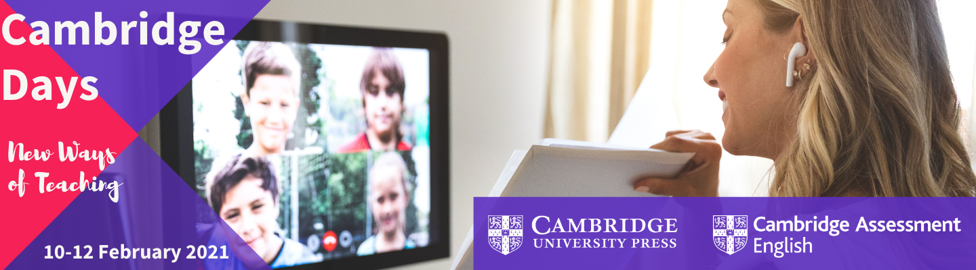
Just last year in February, everyone was together for our 2020 Cambridge Day in Bucharest. Many of the participants had not heard the term "COVID-19", and no-one was able to imagine the implications the pandemic would hold. How our lives - and our teaching - have been affected!
Given the current situation, a face-to-face Cambridge Day can't be organised, as you can well understand. But we are excited to be able to propose our first online Cambridge Day geared to your new classroom needs in these changing times.
Please do join us online for one, two or three evenings of interactive sessions providing you with ideas and solutions for the challenges you are facing in the classroom. Daily breaks will be organised by our partners, Centrul de Carte Straina Sitka, Fischer International and Art Klett - with some nice surprises for the participants! Our Authorised Exam Centres' information will be provided to you as well, as we all know how popular Cambridge English Qualifications are! We'll be sharing info and listening to you, too. Sign up for this year's virtual event CAMBRIDGE DAYS ROMANIA!
We look forward to seeing you among the participants,
Cambridge English
Do you want to take part in our online event? Register now
Programme
Day 1 - Wednesday 10 February
• 17:30 - 17:45 Welcome - Duncan Christelow
• 17:45 - 18:30 Digital Pedagogy - what does it mean for us? - John Mc Neill & Duncan Christelow
• 18:30 - 18:45 Have a break - with Centrul de Carte Straina Sitka
• 18:45 - 19:30 Measuring progress in Speaking and Writing online - Matthew Ellman
• 19:30 - 19:45 Q&A session - Cambridge English
Day 2 - Thursday 11 February
• 17:30 - 17:45 Welcome - Mihaela Fit
• 17:45 - 18:30 Cambridge English Qualifications - step by step - Aniella Giorgiana Busila
• 18:30 - 18:45 Have a break - with Fischer International
• 18:45 - 19:15 The new direction of Exam practice - John Mc Neill
• 19:15 - 19:45 Board, not bored - Matthew Ellman
• 19:45 - 20:00 Q&A session - Cambridge English
Day 3 - Friday 12 February
• 17:30 - 17:45 Welcome - Aniella Giorgiana Busila
• 17:45 - 18:30 Making up for lost learning - doing our best - Sarah Ellis & John Mc Neill
• 18:30 - 18:45 Have a break with Art Klett
• 18:45 - 19:30 Using mobile phones for exam preparation - Greg Wagstaff
• 19:30 - 19:45 Q&A session - Cambridge English
• 19:45 - 20:00 Closing remarks & Prize draw - Aniella Giorgiana Busila & Team
Do you want to take part in our online event? Register now
Download the full programme, information about the speakers and their presentations.
Acest email a fost trimis de către "CENTRUL DE CARTE STRĂINĂ SITKA" către ##UTILIZATOR##. În cazul în care doriți să vă dezabonați sau să raportați un SPAM, click aici

